**IP addressing:**

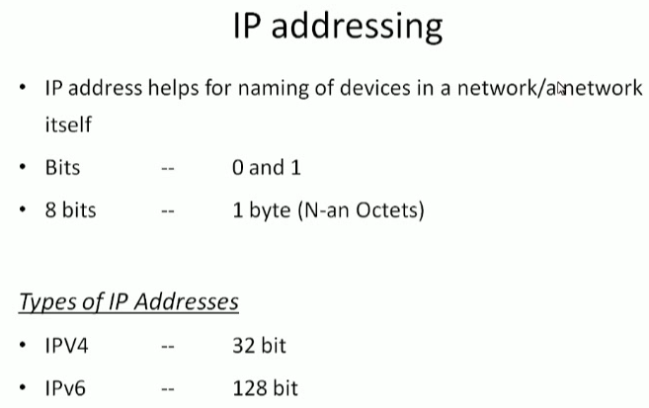

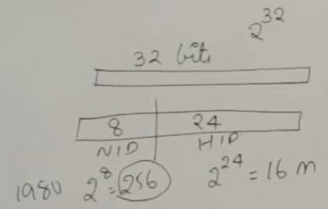

* Ip address is 32 bits. Earlier they have divided it into 8 bits and 24 bits which means as above
* It was in earlier situations, but now it is classful ip addressing manner
* Ip addressing is nothing but a 32-bit number

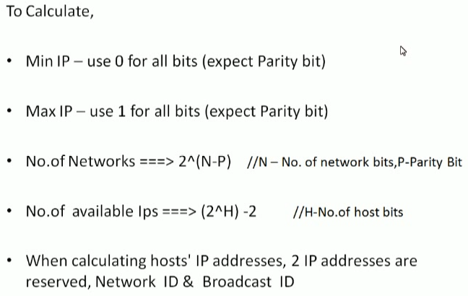

* To calculate the ip address, we have to put all 0 bits for minimum ip calculation and for maximum ip calculation, we have to put all 1
* We calculate no of networks and ips as above image
* Parity bit is constant and never changes
* We ignore 2 bits because the first bit is reserved for network and last one for broadcasting

**Classful manner:**

* In classful manner, instead of dividing into network and host. They have chosen 1st bit which means they divided into two parts
* First part contains first bit and remaining second part contains 2 power 31

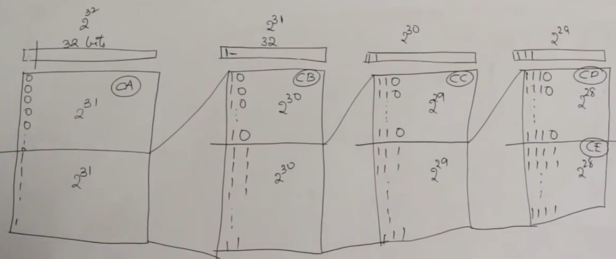

* And in class B, we divide again into two parts. First half contains all 10 and second half contains all 11 and the second part contains remaining 2 power 30
* So, in class A the no of ip addresses is 2 power 31, in class B it is 2 power 30, Class c it is 2 power 29 and class D is 2 power 28
* This is how the ip addressing has been classified into
* There are some types of ip addressing
* One is we can represent it as 32bit as all 0s and 1s or we can convert the 32 bit into a decimal number which is huge
* Or else we can divide it into 4 parts with 8 bits each and convert into decimal and put . in between
* these are called octates. We get 4 octates
* Take the octate and encode into decimal and put . between is also called as dotted decimal representation which is most popular representation
* For binary representation we can easily find the class. If it is start with 0 then it is class A, if it is starts with 10 then class B. like this we can easily find out which class the ip address belongs to

**Class A:**

* As we know class A has 32 bits and they have divided it into 8 network bits and 24 host bits
* And the first bit which is 0 constant as we know
* So, in remaining 7 bits 2 power 7 = 128 network id of class A
* And then 2 power 24 = around 16M ip addresses per network
* We can calculate the network as below

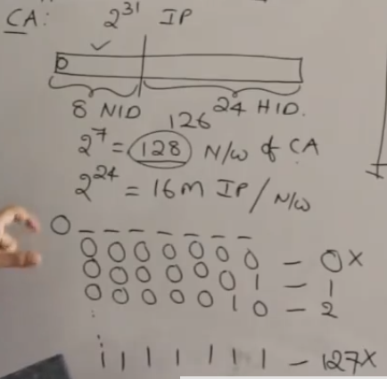

* In class A, first bit is fixed, and they have divided the remaining as above
* 7 ones are 127. It is like 2 power 7-1. 2 power 7 is 128 and -1 =127
* Generally, big organisations used to buy class A ip addresses
* Practically, we don’t use 0 and 127 means first and last. So, the range of class A is 126 (1 to 126) and we can configure 16 M hosts in each network
* If we see any ip address which starts in between 1 and 126, we can say it is class A ip address

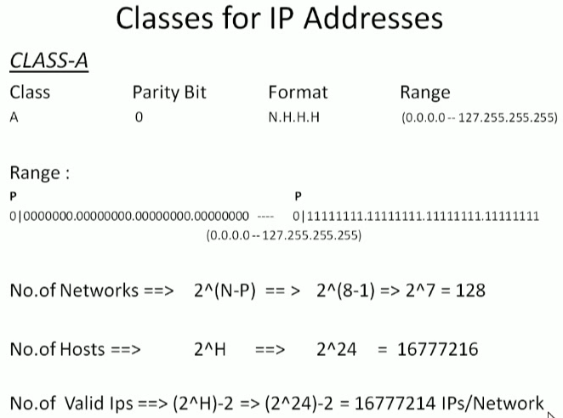

* In general network, the reserved number is 2 but in amazon it is 5

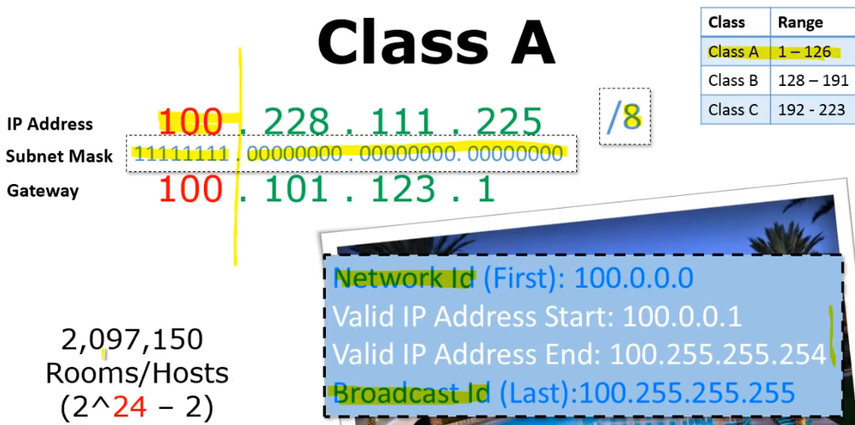

* Subnet mask for class A is 255.0.0.0

**Class B:**

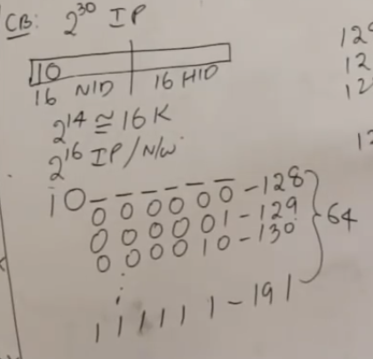

* In class B, 2 power 30 ip addresses are present. we have 30 bits which is divided as 16 network and 16 hosts. 2 bits are fixed here so we get 14 bits of network which is nearly equals to 16k and 16 bits for host ip addresses
* If we want to see the range, need to check first octate, means first 8 bits
* It will be like 1 0 followed by 6 bits
* If have 1 starting, the weight of that is 2 power 7 which means we get 128 and remaining is 6 numbers after leaving 2 bits as constant. Which means 2 power 6-1= 63
* The practical range of class B is 128 to 191

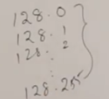

* As above, every number is capable of generating 256 networks

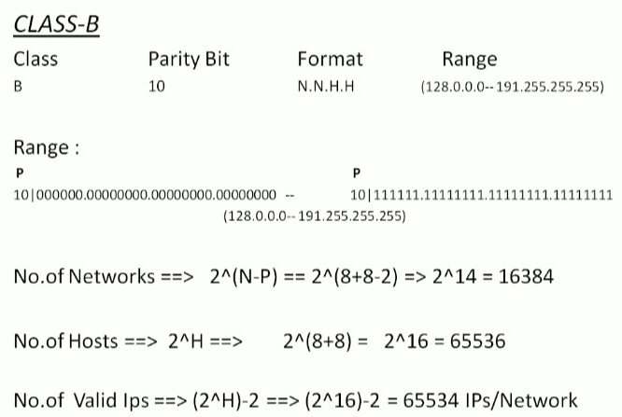

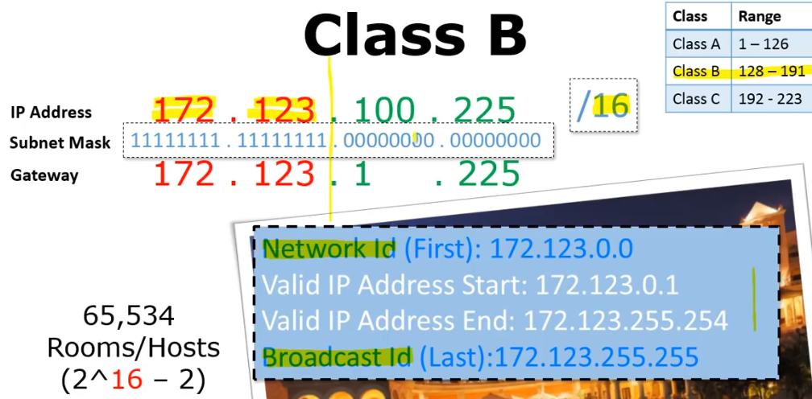

* Subnet mask for class B is 255.255.0.0

**Class C:**

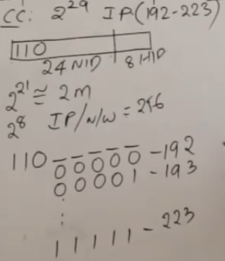

* In class C, 2 power 29 ip addresses are present which is starting with 110
* They have divided it into 24 bits of network id and 8 bits of host id. As 3 bits are fixed, so we get 2 power 21 = around 2M networks we get, and we get 2 power 8 ip addresses we get per network
* The range as above 192 to 223
* The network will be as below

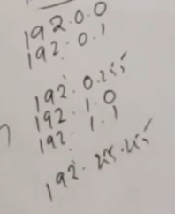

* The ip address will be as above. It starts with 192 which means one number actually represents as 2 power 8 * 2 power 8. Total 2 power 21

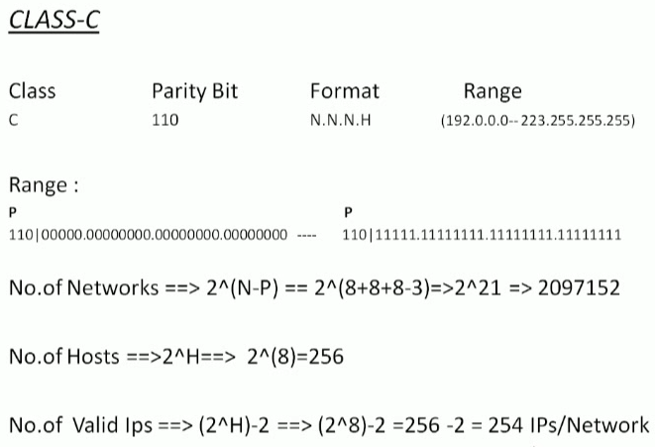

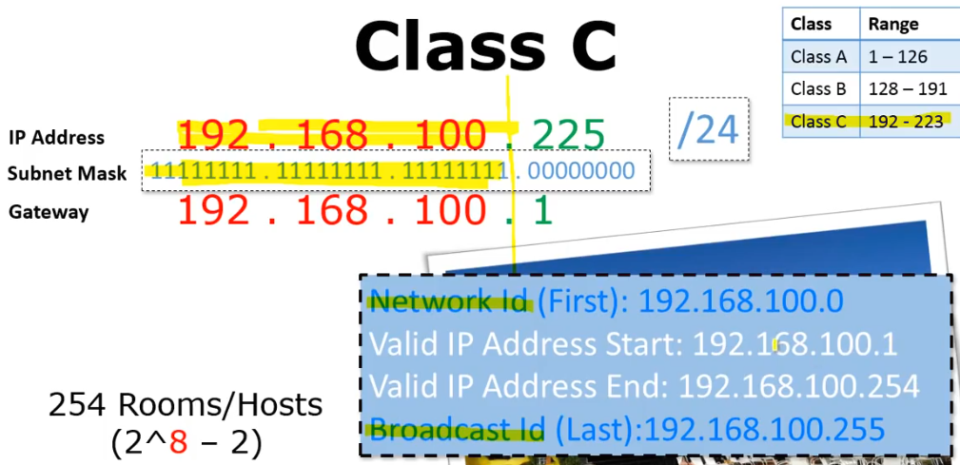

* Subnet mask is 255.255.255.0

**Class D:**

* Class A, B, C are divided into network id and host id
* But class D, E are not divided as that. They just left as it is. We can see the range as below

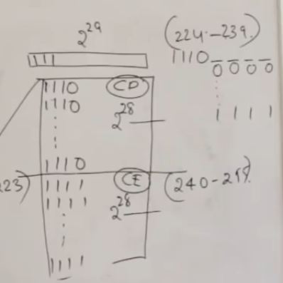

**Note:**

* If we buy any class, we won’t use first and last ip address which means total range – 2

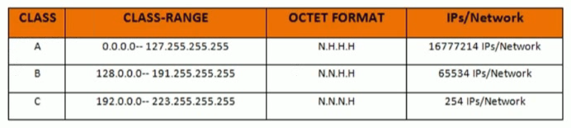

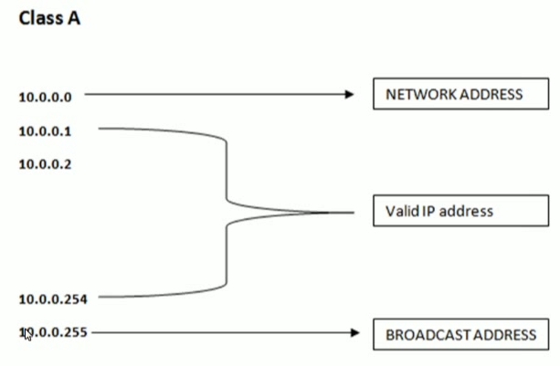

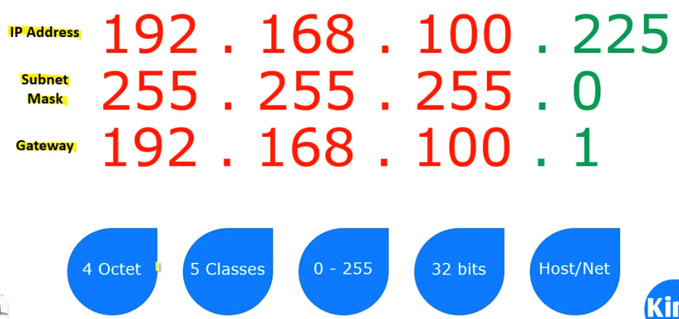

* If IP address needs to communicate with another IP, it needs to go through the gateway. Gateway should be in same network
* For computers, it seen like below which is binary representation
* Above is the dotted decimal representation

